Chapter 14, Problem 80.

- For the circuit in Fig. 14.97, draw the new circuit after it has been scaled by K_{m} = 200 and K_{f} = 10⁴.
- Obtain the Thevenin equivalent impedance at terminals a-b of the scaled circuit at ω =10⁴ rad/s.

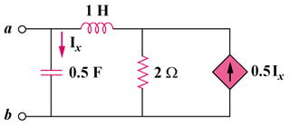

Figure 14.97
For Prob. 14.80.

